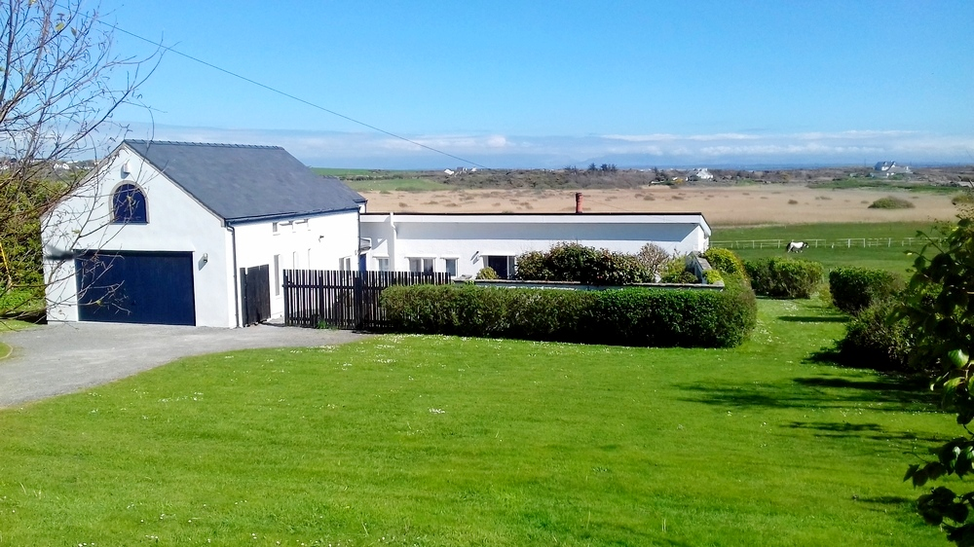

WELCOME TO TY HAF

This file contains all sorts of information you may find useful: do have a read through

Everything you need to know should be in this file. If you find an omission let us know. All the instruction booklets for appliances are in the Green File. This file will be in the third drawer of the adjoining small chest of drawers.

If this is your first visit, please check the layout of house. Drawing on "Information/floorplan" page.

ALARM SYSTEM: See Entry page

MEDICAL: nearest Doctor; Dr WH Roberts London Road Valley Tel 01407 740 706
Minor injuries only : Penrhos Stanley Hospital Penrhos Beach Road Holyhead
LL65 2QA. Tel. 01407 766 000/ 0300 085 0022
Full A & E: Bangor Hospital Hendrewen Road Minffordd
LL57 2PW. Tel. 01248 352 308

DINING ROOM TABLE: Please use mats and coasters with or without plastic table cloth.
The table can extend to seat 12. Should you need to move the table, grip the frame rather than the table top itself.
Undo the two black catches on the inside of the rail. These flip toward the centre and lock the extender wire.
Pull the two halves apart to their full extend without moving the legs.
Lift out the infill panel and turn 90 degrees. This has holes and dowels to match with the table.
Close the sides until panel is tight.
Relock the black catches.

DOGS/PETS:
Dogs only by prior arrangement and please keep them off beds and furniture. Access for wet/dirty dogs (and people!) is through the side door directly into the utility room. Please bring your dog bedding with you and clear up any mess in or out of the house and garden. Remember to keep your dogs on a lead near sheep when walking; the local farmers are very protective of their animals, especially during lambing, and are likely to shoot a dog if loose. Our insurance does not cover damage caused by pets, so please ensure that yours does- i.e. full pet insurance.
Vet: Anglesey Pet Clinic, Cyttir Road Holyhead LL65 2SY. Tel 01407 764 999

HEATING/HOT WATER: You will arrive to a warm house and hot water: we will remote control the heating and hot water so they are on when you arrive.

See separate page for details.

ELECTRICITY: The main switch board is in the boathouse above work-bench; this board covers the new part of the house, bunk rooms, utility, boathouse and kitchen.
There is a second board for the remainder of the house at high level in W/C 2.
Kitchen fridge socket at low level inside pullout larder cupboard.
Dishwasher switch in l/h cupboard dining room side of units.
There are occasional power cuts - candles, bulbs etc can be found on the top shelf in the cupboard by the front door. Torches under the table in the hall.

TELEPHONE: This is in the sitting room. Telephone calls are on a trust basis, local calls are free. international calls and calls to mobiles are not free. Please use the tin.

FIRST AID x 2: Black bag on shelf above fridge in kitchen.
Green first aid bag in wall cupboard in utility room.
Please, if you finish/nearly finish an item, either leave a note or buy a replacement.

FIRE BLANKETS: On wall to right of door in kitchen. Also, there is one in Utility room.
Fire extinguisher below fire blanket in kitchen also in boathouse.

FIRE PREVENTION: See Fire Brigade leaflet.

FIRE IN SITTING ROOM: The Jetmaster fire only burns wood (NOT COAL). After your initial allowance of two baskets/bags, which should be in the boathouse, please buy your own (dry logs not wet wood) from suppliers e.g. Looms (roundabout above A55 past Four MB) and Stermat (Valley) (also others).

Cleaning brush and firelighters in hall cupboard or by fire.
To lay fire, scrunch up newspapers, add a firelighter, lay sticks on top and some wood. Then top up to get a good fire going. Please leave a minimum 2cm ash in the pan to improve performance and protect the ash pan. To remove ash there is a copper bucket and shovel in the boathouse.

Fireguard should be used- sparks can travel quite a distance.

GAS CYLINDERS: Calor gas is used solely for the hob. There are two cylinders and a changeover valve behind the black gate to the left of front door. If one of the cylinders runs out the valve will change over automatically and the arrow pointing to the empty cylinder will turn red. If you see this, please lift off the front, change the valve to point the other way. There is no need to open or close cylinder valves - just turn the knob on the wall through 180 degrees.
Please inform us when you have had to change over. We will arrange a new cylinder. New cylinder fitted 3/8/23.

GLAZING: All glazing throughout the house complies with current regulations. All doors and glazed panels are toughened glass.

KEYS/locks: Most keys are kept in the hall cupboard.
Red topped for external door locks, including dining room doors.

The boathouse has a Blue topped key, on hook at top of steps in utility room.
Please note that the main boathouse door is bolted on either side before you try to open it. The wireless fob for this is just inside the entry door on the right side.
Before opening, check no cars on the drive are too close.
A spare fob in hall cupboard in case battery is flat. Only re-bolt doors when you finally leave.
Window lock keys on yellow tags in hall cupboard or in bedrooms.
There are identical keys (Anglesey key tag) to sunroom and sitting room sliding doors. When locked, the handle should be up.

MAINS WATER: Stop cock under sink in utility room just above floor level. Alternatively at top of drive l/h side under manhole cover.
Cold water to boiler adjacent to boiler, right of cylinder.
Cold water to bathroom electric shower in loft, access via hatch in bathroom, ladder in boathouse.
Outside tap - ballofix valve under utility room sink, use a screwdriver.
Our water is metered - don’t go short but use sensibly, excessive use of water is not good for the septic tank.

SMOKE ALARMS: Mains operated and interlinked in corridor, utility room and top of loft stairs.

SEPTIC TANK:
The tank does not like excessive use of chemicals e.g. bleach, washing powders, shampoo, gel etc.
We have very soft water so not much detergent is required.
Please do not flush away nappies, wipes and sanitary items etc.

TORCHES: One in hall under pine table. One in boathouse by heating boiler,

OUTSIDE: Two lights triggered by movement detectors, one outside front door and one on corner of boathouse. The front door one can be switched to permanent "on" by double clicking the switch inside the hall cupboard to your left.
A third light outside utility room door requires switching on/off manually, the switch is inside the door.

KITCHEN, CLEANING, COOKING, WASHING
Green file containing instructions for equipment in 3rd drawer of small chest in dining room.
When cleaning please don’t use abrasive cleaner on the knob markings as these gradually wear off.
We prefer you to wash large grill pans, racks etc in the utility room sink. Cip, washing up liquid, brillo pads should be there.

KITCHEN LIGHTS: The switch for the under cupboard lights is to right of oven.
The high level bulbs are MR16 GU3 LED and there are spares in the hall cupboard. Since you need the tall stepladder in the boathouse, you may wish to leave them to others. Please let us know though. Thanks.

CONSUMABLES: sauces, loo rolls, dishwasher tablets, etc – anything in the cupboards (except any beer, wine or spirits) is there for your use but please replace anything that has run out or nearly finished with an equivalent item

DISHWASHER: Instructions in green folder. Powder, liquid or tablets under sink.
On leaving, please leave the door ajar by putting a wooden spoon in place to keep the machine aired.

WASHING UP: For those who prefer to use a washing up bowl there are two in utility room and a wire plate rack hangs in the hall cupboard.

FREEZER: In utility room and small top of fridge in boathouse.

FRIDGES: One in kitchen, leave switched on.
Second in boathouse, at end of your stay please empty this and switch off with doors held open.

WASHING MACHINE: In utility room. Instructions in wall cupboard above. Washing powder/tablets/liquid ditto. Please switch off after use.

TUMBLE DRYER: Utility room, instructions in wall cupboard. We try to use this for finishing the drying process, weather permitting, rather than for drying from wet.

Please clean off the lint filter after each use, and replace, arrows to the front. See instructions. Failure to clean the filter can cause a fire!!
Please do not turn off before the cycle has finished as this damages the heating element.

WASHING LINE: Rotary line in garden, peg bag on hook. Or use the rack in utility room- adults only.

IRON AND IRONING BOARD: These are in utility room. You can use tap water for steaming but please empty any remaining water after use.

VACUUM CLEANER: In hall cupboard. Cylinder requires frequent emptying.

CLEANING, COMPOST AND RECYCLING

ANTS: Ant powder is in Utility room cupboard.

CLEANING THINGS, BROOMS, TOILET ROLLS: Mostly in utility room or hall cupboards. Spare soap, washing up liquid, dishwasher things in hall cupboard.
Toilet rolls in large clear polythene bag hanging on hook in hall cupboard.
Brooms, “hoover”, dustpan and brushes in hall cupboard, other brooms etc in utility room.

COMPOSTING: If you wish, fruit and veg peelings only can be emptied into our own black compost bin on the far side of boathouse. Please no food of any kind

RECYCLING: Please read the local authority cards referring to this. One in hall cupboard, one on fridge
The recycling trolley is in the courtyard or up by the oil tank .
The bins are emptied early on a MONDAY, including Bank Holidays, and it is best if you take the bin up onto the road the night before even if you have only just arrived, and bring it down afterwards.
No food in any bin except the brown one and in the special compostable bags found in kitchen drawer.
Black, green and brown (food waste) bins are also by the oil tank.
To save trouble, there is an orange box in the hall cupboard which acts as intermediate holding.
Large clear plastic bags are in the hall cupboard to take any overflow from these boxes (not the black bin e.g. nappies); the council will only accept the clear bags for recyclables.
Should you have very large quantities of recycling, there are bins in the Valley car park, or even Gwalchmai Recycling Depot, A55 J.5 and follow the signs.

GASKELL BIN: This is a yellow top wheelie bin only for use when the others get full. It is emptied from where it is on a Friday. See notice in house.

BREAKAGES and SPILLAGES: Accidents do happen! Please replace anything you break with an equivalent item or let us know and we can deduct it from the Bond.
There is a special carpet spill bag in the hall cupboard with full instructions inside.
If there is a major catastrophe e.g. Window breakage or a flood, please ring the contact numbers, 0151 625 4668 or 0151 638 8741 or mobile 07557 673 660 or 07974 235 099.

MISCELLANEOUS EQUIPMENT

BARBECUE: In boathouse together with implements. Please clean before you leave, ready for the next tenant.

BICYCLES: Two bikes in the boathouse which you are welcome to use reasonably. Tyre pump either on work bench or a windowsill.
Please wash down the bikes and dry off if you have been on the beach or through mud. We do not provide helmets.

BUNK-ROOMS: Two fall protection guards and two portable cots are under the bunks.

CARD TABLE: In the hall cupboard. It is a bit wobbly so take care.
Bridge cloth, some cards and scorers in cupboard in sitting room.

GAMES AND TOYS: Most are in the loft playroom, including jigsaws, dominoes, twister, Scrabble x 2, Monopoly backgammon, badminton racquets and shuttlecocks.
Croquet set, giant Jenga and Padder Tennis in boxes in boathouse.

HIGH CHAIR: In sail loft.

LIGHT BULBS: Hall cupboard, top shelf. Please use only LED bulbs in everything- we hope they won’t need replacing as regularly. And they keep the electric bill down. Kitchen are MR16 GU3, shower room GU10 cool white.

PICNIC THINGS: Paper plates, bowls, plastic glasses in one of the top kitchen cupboards.

PUSH CHAIR: Small Maclaren buggy in boathouse sail loft together with a red waterproof cover.

SUN UMBRELLAS: Two, green and white, in boathouse by side door. Please only use these in conjunction with the tables as they blow over very easily and then break the shaft.

SAND PIT: Buckets and spades etc in a box either in boathouse or the loft. Please re-cover the sandpit on your leaving.

SUN LOUNGERS: Either in hall cupboard, sun room or the loft. Also some lightweight folding chairs.

TABLE TENNIS: Set up in the boathouse sail loft. Bats and balls in the “oakleaf” pattern fabric cotton bag.
Please switch off the light when finished playing.

TELEPHONE: On cupboard in sitting room. Directories in the cupboard.

OUTSIDE

FIELD GATES: Please leave closed when not in use.

GRASS CUTTING and GARDENING: This is done by GMS (Jackie Hannaby), ideally before you arrive, though due to variable weather this is not always possible.
Should they come during your stay, could you cooperate by moving cars off the grass onto the drive, please.

PARKING: At the top of the garden (parallel with the road) is an area of harder ground, please park here when possible. Please do NOT drive around the lawn to go out but reverse back on to the drive.

LIVESTOCK: There are usually two horses in the field, Flo and Treacle. Please don’t feed either unless you have spoken with the owner, Mrs. Lesley Webster who visits them daily. In emergency, please ring Lesley or Ron Webster 01407 740 223 or 07485 028 772

April 2024.

